Annual General Meeting (AGM)
This year, our Society AGM will take place on Thur 24th Sept 2026 at the Pitcher &
Piano (formerly the HP Unitarian Chapel), High Pavement, Nottingham NG1 1HN.
The AGM is an essential Society function and is an important opportunity for the
membership to influence the future direction of the Society. As the Society wrestles with the inevitable problems of falling membership, the opinions of our members become increasingly important.
The AGM (which is necessarily restricted to paid-up members only) will be followed by a Lunch (optional and open to all). After this, our Archivist, Graham Wybrow, is hoping to organise a brief tour of the original School Buildings (similar to that at our April meeting). However, this is not yet confirmed. If not possible, he will, instead, give a short talk on the history of the schools. Graham will also have some postcard sized photos of the Gainsford Crescent site for sale and, also, some Society Ties.
Wives, partners and guests are welcome to attend this event. We do hope to see you with us.
TIMETABLE: 11:45 Arrival (for 12:00 Noon)
12:00 to 12:45 AGM (Members Only for Voting)
12:45 to 1:45 Lunch (All welcome)
1:45 to 2:30 History of School Buildings (Tour / Lecture)
2:30 Nominal end of organised activities.
It is hoped that visitors will take the opportunity to stay on longer to informally socialise / reminisce and talk to the management committee. The venue doesn’t close until 11 pm !
REPLY: If you wish to attend, would you please return the attached Reply Slip or alternatively (if convenient), notify our Chairman John Chambers by email at john08chambers@gmail.com or our Treasurer Michael Johnson by email at mrj1953@outlook.com giving the same information as on the reply slip. If you are
pre-ordering Lunch, please reply no later than Sat 19 Sep 2026.
PAYMENT: This should be made by CHEQUE made payable to “High Pavement Society”, sent to the
Treasurer Michael Johnson, 12 Gainsborough Road, Winthorpe, Newark, Nottinghamshire, NG24 2NN.
OR: By Bank Transfer to Account Name: High Pavement Society, Sort Code: 30-97-55 Account No:
00397178 (On the back of the Cheque or Transfer please give the Reference “HP Soc AGM Lunch”).
----------------------------------------------------------------------------------------------------------------

AGM Lunch 2026 - Order Form

Name:.........................................................................................Phone:................................…

E-mail: .....................................…………………………………………………Date:………………………

Name of Guest 1:……………………………………………………….

Name of Guest 2:……………………………………………………

I wish to Pre-Order food Please order the following items in my name. I require the following:
(Please enter the Menu Number of the selected item)
Member Guest 1 Guest 2
Main Course

Dessert

Payment: I am making payment for this food by CHEQUE / BANK TRANSFER (please delete as appropriate)

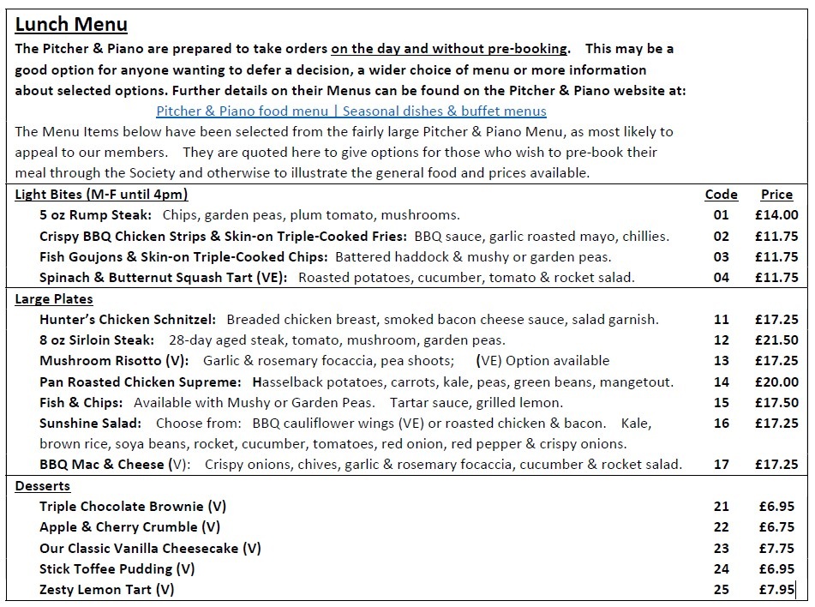
AGM AGENDA
1. Minutes of the last meeting.
2. Matters arising.
3. Chairman’s report. John Chambers.
4. Treasurer’s report. Michael Johnson.
5. Secretary’s report. Gerald Taylor.
6. Webmaster’s report. Lawrence Milbourn.
7. Archivist’s report Graham Wybrow.
8. Election of Officers and Committee.
9. AOB.

