PRESENTATION OF THE 2015 HIGH PAVEMENT SOCIETY AWARDS
A delegation from the High Pavement Society attended the ceremony held at the High Pavement Sixth Form Academy on September 8th when its four prize awards were presented. Denise Jelly, Principal of the High Pavement Academy, welcomed the visitors, who included parents of some of the student recipients.
The Awards were as follows:
High Pavement Society Awards for Excellence (for highest achieving female and male A-Level students) awarded to: Qianwen Lu and Adam Barbarowicz
Stanley Middleton Award for Literary Achievement (for the highest achieving student in English Literature) awarded to: Rose Marie Lowther
Ken Bateman Award for Engineering (for the highest achieving student pursuing Engineering or related studies) awarded to: Yun-tang Ng
The presentations were made on behalf of the Society by the Chairman, Ken Kirk, who said: `It's a pleasure coming back to High Pavement, there's a real sense of nostalgia. The students have worked extremely hard for their qualifications and we wish them every success for the future. We hope former High Pavement students will join the society in the future to ensure the society lives on for years to come.'
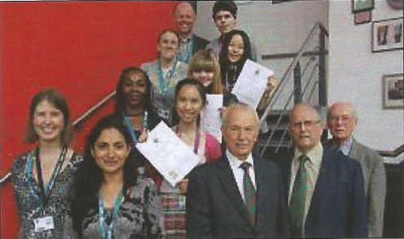
The winners proudly display their award certificates as they pose with supporting members of the Academy staff. Standing on the right hand side of the staircase the winners are (from the top):
Adam Barbarowicz
Qianwen Lu
Rose Marie Lowther
Yun-Tang Ng
In the foreground are the three members of the Society Committee.

