Award of 2007 High Pavement Society Prizes

The 2007 High Pavement Society Prizes for Excellence were presented on Friday 31st August during a short ceremony held at High Pavement Sixth Form College. Two prizes of £150 each are awarded, one to the best performing female student and the other to the best performing male student, in this year’s A-level examinations at the college.

This year’s winners were:
Norjihan Kamaluddin, 18, who achieved grade ‘A’ in Mathematics, Chemistry, Physics and Biology; also ‘AS’ level in Mathematics.
Jonathan Phillips, also 18, who achieved grade ‘A’ in Mathematics; grade ‘B’ in Chemistry Physics and Biology; grade ‘C’ in Further Mathematics.

In the absence of Liz Leek, Director of High Pavement College, due to illness, the winners were introduced by Geoff Hall, Principal of New College Nottingham. The awards were presented by Ken Kirk, Chairman of the High Pavement Society, who wished the recipients every success in their future careers.

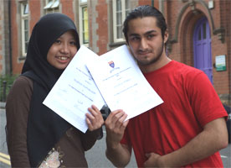
◄ Norjihan Kalmuddin and Jonathan Phillips show their award certificates after receiving their High Pavement Society Prizes for Excellence.

Norjihan plans to take a gap year during which she will gain work experience in medicine at Nottingham’s Queen’s Medical Centre. She will reapply to gain a place to study medicine at university next year.

Jonathan also wishes to study medicine and is considering a degree course at Charles University in Prague.

High Pavement Sixth Form College is a constituent part of New College Nottingham (ncn).

