Presentation of the High Pavement Society Prizes
for 2008

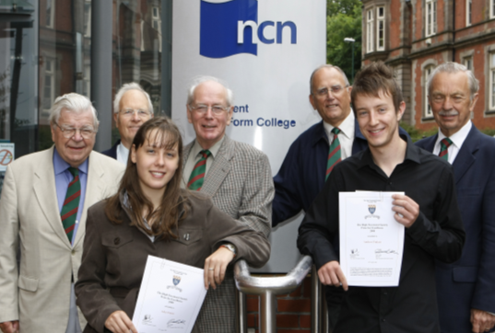
The presentation of the year’s High Pavement Society Prizes for Excellence took place during a short ceremony held at High Pavement College on August 19th. The presentations were made by HPS Chairman Ken Kirk (right) to Alice Foster and Andrew Pinkett in the presence of members of the Committee (L to R): Arnold Brown, Robin Taylor, Colin Salsbury and Noel Gubbins.

Both recipients of the £150 awards will study Physics at university. Alice will go to Imperial College, University of London and Andrew to Nottingham University. On behalf of the Society Ken Kirk wished them every success in their future careers.

