The highest achieving male and female ‘A’ Level ncn High Pavement students of 2011 have been awarded a ‘High Pavement Society Prize for Excellence’.
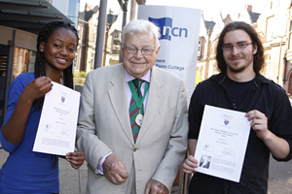
Anastasia Lubke and Steve Pollicott with President
of the High Pavement (HP) Society, Arnold Brown
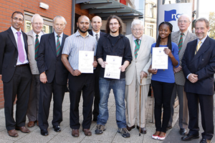
Amarjit Basi, ncn Principal and Chief Executive;
Robin Taylor; Ken Kirk (HP Society); Humayum
Morshed; Robin Kempster, Deputy Head of HP;
Steve Pollicott; Arnold Brown (HP Society);
Anastasia Lubke; Colin Salsbury (HP Society) and
Martin Slattery, Director of HP
The awards were instituted by the High Pavement Society, which was founded in 1989 to recognise the long tradition of academic excellence associated with the name ‘High Pavement’ throughout the years - from 1788 to date.
Anastasia Lubke was awarded highest achieving female after receiving three A* grades in Maths, Further Maths and Chemistry and two A’s in Physics and Biology. These grades secured her place at the University of Leicester to read Medical Microbiology.
Highest achieving male, Fahim Saber, is currently in Canada studying Electrical Engineering at Waterloo University. He achieved four A’s in Maths, Further Maths, Physics and Chemistry. Fahim’s uncle, Humayum Morshed, collected the award on his behalf.
The Stanley Middleton Award for Literary Achievement was presented to Steve Pollicott for achieving an A in English Literature. He has progressed to the University of Lincoln to study English.

