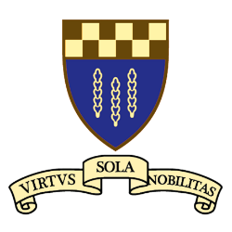
Return to the Good Old Days: Watch Paviors at Rugby.

Hello everyone,
We are delighted to confirm that we are having a shared event with Paviors Rugby Club, formerly Old Paviors RFC, who still have a lot of our former students as members.
The plan is as follows:
Date: Saturday 31st January 2026.
Venue: Paviors rugby ground, Burntstump Hill, Arnold, Nottingham NG5 8PQ.
Schedule:
1 pm: meal of pie, chips and peas.
2:15 pm: kick off against West Bridgford.
Halftime: cheese and biscuits.
We are hopeful of receiving as main guest John Pallant. John was at High Pavement from 1955 till 1962, played for Paviors and for Nottingham Rugby, and was capped 3 times for England in 1967. He was also an All England Schools’ hammer throwing champion in 1961, with a record throw, and later Director of Sport at Merchant Taylors’ School. Another ex-High Pavement scholar and highly respected physiotherapist, Norman Collins, is presenting to the club a framed England shirt, the one that John wore versus France at that time.
Many Paviors R.F.C members are ex-High Pavement and we are confident that a good number of them will attend.
We do ask for strong support from our own members for what is sure to be a happy and enjoyable occasion. Remember to wrap up well for the outdoor part of the event!
The price of the meal is £10.
Please book in with me, John Chambers, and make payment to our Treasurer and Old Paviors’ Rugby man himself, Michael Johnson.
Bookings should be made by Friday, 16th January 2026 to john08chambers@gmail.com
Payment should be by cheque payable to the Society and sent to Michael or by bank transfer. Details below.
Michael - 12 Gainsborough Road, Winthorpe, Newark, Notts. NG24 2NN
Bank account - The High Pavement Society. Sort Code 30-97-55. A/C 00397178
Yours, John Chambers.

