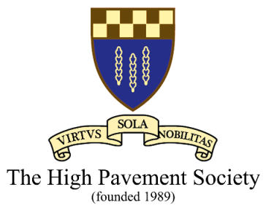

6th-Form College - 50th Anniversary
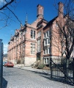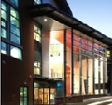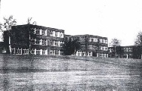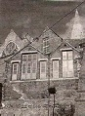
- High Pavement 6th-Form College came into being in Sep 1974, making 2024 the College’s 50th Anniversary.
- The High Pavement Society, in collaboration with Nottingham College, would like to celebrate this event with an evening looking at the long distinguished history of the College and Schools since their foundation in 1788, almost 240-years ago.
- PowerPoint presentations will be used to:
  - explain the long and fascinating history
  - show a “video tour” of the Gainsford Crescent site - including never before seen photography
  - look at distinguished Alumni who “reached great heights” thanks to HP
- The celebration will be held at the College premises, Chaucer Street, Nottingham. NG1 5LP on the evening of Tuesday 11 June, 7.00 pm to 9.30 pm.
- All current and former pupils and staff of the College / Schools are welcome. Do come and join us. Pre-booking essential. Please contact:
John Chambers – john08chambers@gmail.com
Graham Wybrow – gm.wybrow@btinternet.com
Colin Salsbury – colin.salsbury@outlook.com

