THE HIGH PAVEMENT SOCIETY PRIZES 2010

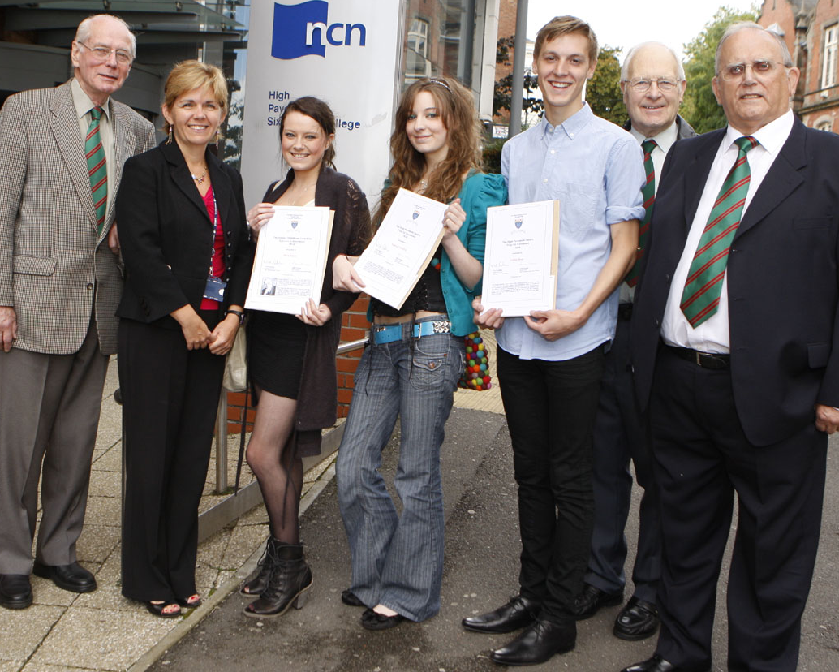
Members of the committee of the High Pavement Society, took part in a short ceremony at High Pavement Sixth Form College, Chaucer Street, on September 7th to present the Society’s Prizes for 2010. The Society was represented by Noel Gubbins (General Secretary) supported by Robin Taylor and Colin Salsbury.
At the HP Prizegiving
(L to R): Colin Salsbury; Julie Ashton; Beth Payne; Laura Corcoran; Eddie Ross; Robin Taylor; Noel Gubbins.

Laura Corcoran received the cheque for £200 for the best female student in the ‘A’ level examinations this year. She achieved four A* grades in Biology, Maths, Further Maths, and Psychology. These grades secured her place at the University of Cambridge to read Criminal Psychology, Sociology and Politics.

Eddie Ross also received a cheque for £200 for the best male student and achieved A*, A, A and B in Maths, Physics, Further Maths and English Language respectively. He is to study physics at the University of Birmingham.

Beth Payne received a cheque for £150 as winner of The Stanley Middleton Memorial Prize for Literary Achievement awarded to the student with the best performance in English Literature at ‘A’ level. She achieved A* grades in English Literature and also in English Language. She will study English and American Literature at Goldsmiths College, University of London.

The college was represented by Sally Francis, Interim Head of High Pavement College, Robin Kempster, Deputy Head and Julie Ashton, Deputy Principal of New College Nottingham (of which the High Pavement College is a constituent part). Parents of the students were present to witness the presentations. The Society offers its warmest congratulations to all the prize-winners and best wishes for success in their chosen careers.

