Useful tips for printing the Website Edition
The text is set up in 14 pt type because our printing firm then reduces it to fit on A5 pages and the text would otherwise be unreadable. This is the format in which it appears on the website.

If you want to print it on A4 sheets as two A5 pages and 'save paper and ink' you should
- Set 'Orientation' to Landscape in the File – Print Setup dialog . This step is not always necessary depending upon your printer. Don’t forget to change it back to your usual setting when you have finished.
- Set up the pdf pages for printing by using File - Print. The 'Dialog [sic] box' will open. It will look something like this. There could be a Printer icon on the menu bar that will do this.

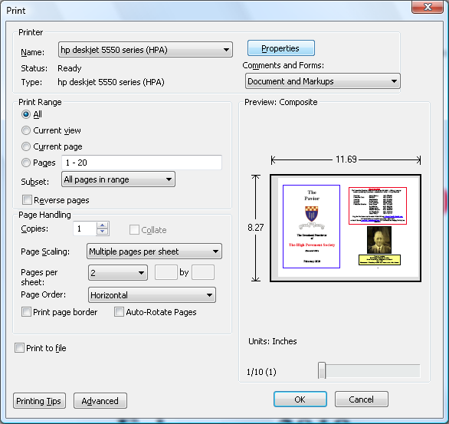

- In 'Print Range' enter the pages you want to appear two-at-a-time on an A4 sheet. Maybe it is better to do a single A4 at a time, pausing to think between each - I do!
- In 'Page Scaling' set it to Multiple pages per sheet
- Below this where it says 'Pages per sheet' set it to “2” and choose page order “Horizontal”. The window on the right then shows how it will look when printed. Depending on your version of Adobe Reader, you might have to choose “Pages per sheet” as “Custom” and set the number as “2 by 1”.
6. Click on the OK button and stand back.

NB if you want (ever) to print it as a booklet you must choose “booklet” instead of “Multiple pages per sheet”. It should sort out the order for you so you can fold it into a booklet.

