Highest Achieving Female was awarded to Sarah Topley, who is set to study architecture at Newcastle University after achieving A*, A, A, C grades in Art & Design (Double Award), English Language and History. She said: “It was completely unexpected but a lovely surprise to receive recognition for my hard work. I’ve really enjoyed my time at High Pavement; it has a vibrant, friendly atmosphere and tutors who are willing to go the extra mile to support you. It’s definitely been a good stepping stone for university.”
R H was awarded The Stanley Middleton Award for Literary Achievement after receiving two As and a B grade in English Language, Sociology and English Literature. These grades secured her place at the University of Warwick to study Philosophy. She said: “I was shocked to find out I’d won but really pleased because I love English. I’m going to put the £150 prize towards a laptop ready for when I start my new course at university.”
Highest Achieving Male went to Mekael Tuabin for his A*, A and three B grades in Maths, Further Maths, Physics, Chemistry and Biology.
New addition, the Ken Bateman Engineering Award, was presented to Oliver Reynolds, 19, who achieved two A*s and A grade in Maths, Physics and Further Maths. He is progressing to Durham University to study Mechanical Engineering.

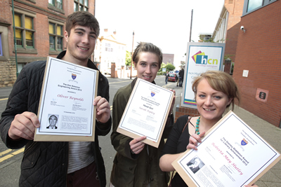
Oliver Reynolds, Sarah Topley and R H
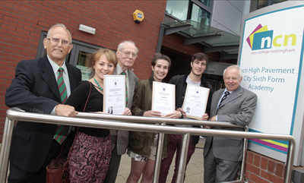
(l-r) Noel Gubbins, Roberta H, Colin Salsbury, Sarah Topley, Oliver Reynolds and John Elliot

